**Analyzing Salary Growth Patterns Based on Work Experience**

**Table of Contents**

1. Project Objective
2. Tools and Technologies Used
3. Data Cleaning & Pre-processing
4. SQL Query Implementation
5. Excel Visualization & Dashboard
6. Key Insights & Trends
7. Conclusion
8. Future Scope

**1. Project Objective**

The goal of this project is to **uncover salary growth patterns** based on **years of experience** using a structured data analysis approach. This includes:

* Exploring relationships between experience, industry, job title, gender, and compensation.
* Leveraging **SQL** for querying and **Excel** for visualizations.
* Delivering insights to assist **HR professionals**, **policy makers**, and **job seekers**.

**2. Tools and Technologies Used**

| **Tool** | **Purpose** |
| --- | --- |
| SQL | Data extraction, querying, segmentation |
| Excel | Data cleaning, pivoting, dashboarding |
| Charts | For visual trend analysis |
| Tables | For summary and comparisons |

**3. Data Cleaning & Pre-processing**

The raw data underwent a thorough cleaning process involving:

* **File Size & Key Columns Identification**:  
  Focused on relevant columns such as Job Title, Salary, Gender, Experience, Country, etc.
* **Handling Missing Values**:  
  Used filtering, interpolation, or removal based on severity and context.
* **Standardization**:  
  Standardized categories like gender ("Male", "Female"), job titles, city names, etc.
* **Outlier Treatment**:  
  Detected extreme salary values using boxplot methods and treated accordingly.
* **Final Output**:  
  A cleaned dataset ready for SQL querying and Excel visualization.

**4. SQL Query Implementation**

A set of SQL queries were designed to extract specific insights:

1. **Average Salary by Industry and Gender**
2. **Total Salary Compensation by Job Title**
3. **Salary Distribution by Education Level**
4. **Employees by Industry & Experience**
5. **Median Salary by Age Range & Gender**
6. **Top-Paying Job Titles per Country**
7. **Average Salary by City and Industry**
8. **% of Employees with Additional Compensation by Gender**
9. **Total Compensation by Job Title & Experience**
10. **Average Salary by Industry, Gender, and Education Level**

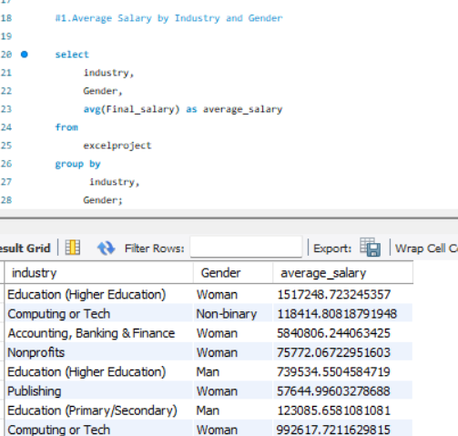

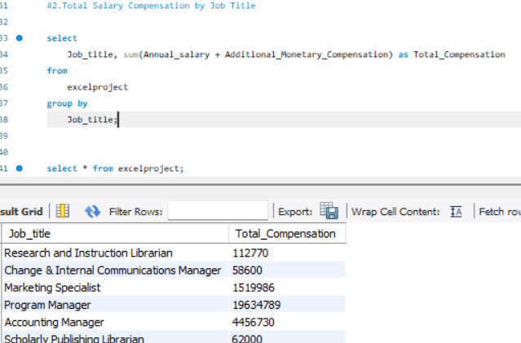

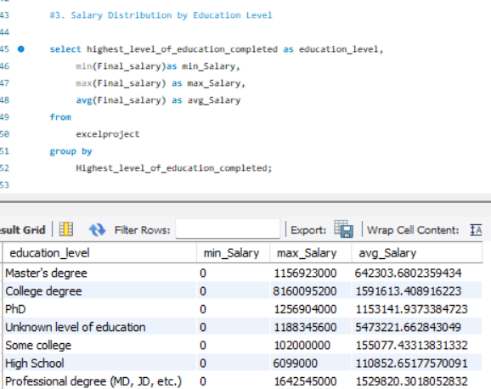

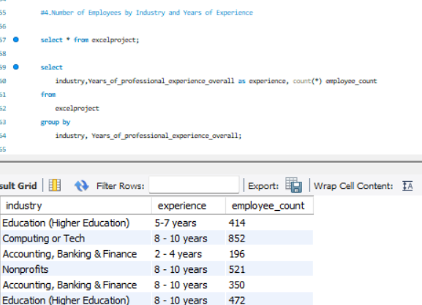

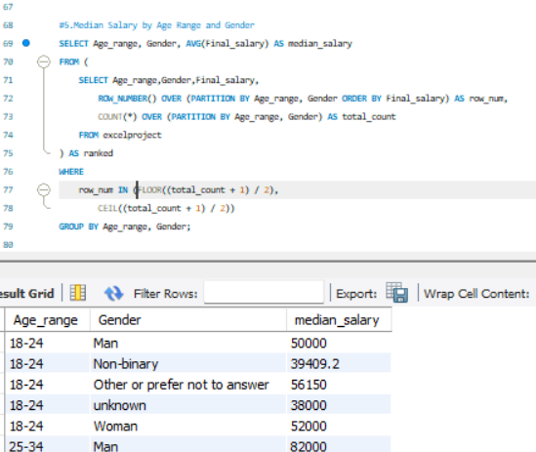

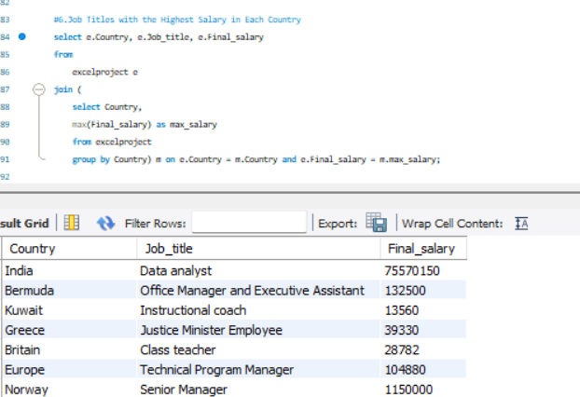

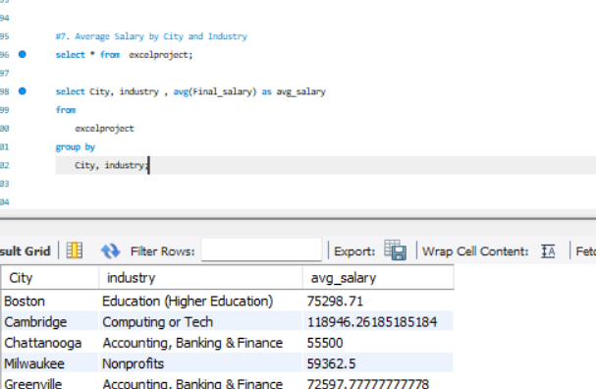

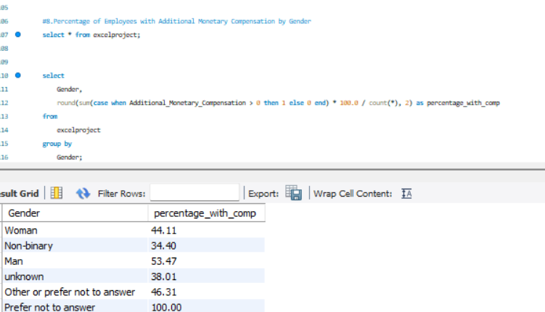

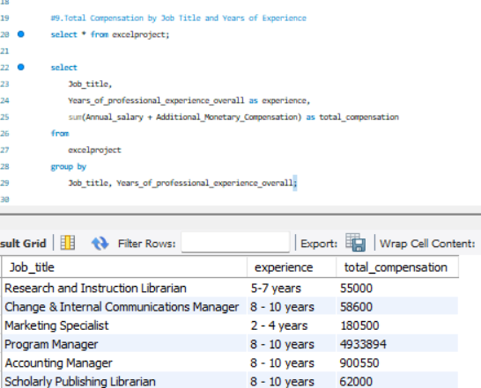

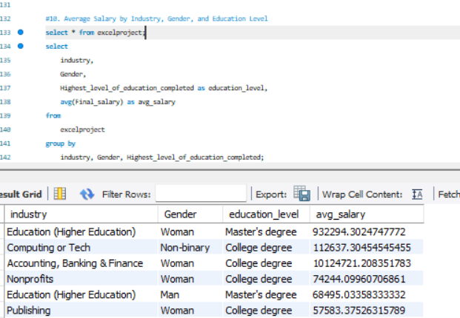

**5. Excel Visualization & Dashboard**

Using **pivot tables** and **charts**, a dashboard was created to display:

* Salary trends across industries
* Comparative graphs by gender and education
* Filters for city, country, and experience
* Bar/line charts for compensation trends

This visual dashboard supports interactive exploration and storytelling with data.

**6. Key Insights & Trends**

1. **High-Paying Industries**:
   * **Tech** and **Finance** dominate in compensation.
2. **Gender Pay Gaps**:
   * Some industries show **women earning more** than men.
3. **Top Roles**:
   * **Product Managers**, **Engineering Managers**, and **Data Scientists** are the top earners.
4. **Remote Work Insight**:
   * Remote workers earn **equal or higher** than onsite roles.

**7. Conclusion**

This project successfully:

* Mapped out **salary trends** based on various factors like experience, industry, and gender.
* Identified **inequities** and **opportunities** in the job market.
* Provided meaningful data to **job seekers** to benchmark salaries.
* Enabled **decision-makers** to implement fair compensation strategies.

**8. Future Scope**

* Incorporate **machine learning models** for salary prediction.
* Expand analysis to include **benefits**, **bonuses**, and **work-life balance metrics**.
* Build **interactive dashboards** using Power BI or Tableau.
* Integrate **real-time datasets** via APIs for up-to-date insights.